Oracle Streams
One-Way Schema Level Streams Replication.

Here in this document we are explaining step by step procedure on how to set up one-way schemas level replication between two users of different databases.
Software and OS Info.

Product:Oracle 11.2.0.3 Enterprise Edition.
Operating system :Windows 2003.
Source DB Name &DB Usert:First & streams_user
Target DB Name & DB User:Second & streams_user.

Prerequisites:

- Password File Should be present with same sys password for both DBS.
- DB should be in archive log mode.
- Check the Supported data types in replication.

Step1:
Before configuring streams between two databases users ,Two databases should be able to do tnsping with Each other.
Note: I have my source and target DB are in same machine.

Screen Shot S.1.1.

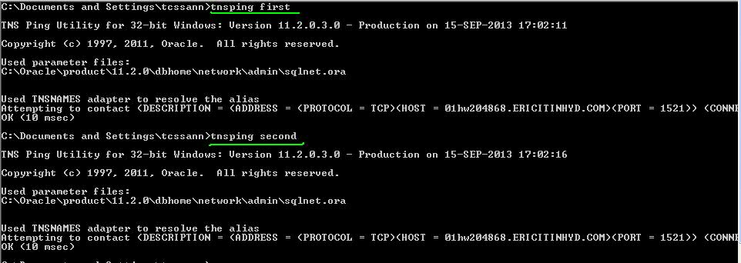

Step 2:
Create the Streams Administrator on both sites as specified in screen shots.
Script No 1:
create user STRMADMIN identified by STRMADMIN;
ALTER USER STRMADMIN DEFAULT TABLESPACE USERS
TEMPORARY TABLESPACE TEMP
QUOTA UNLIMITED ON USERS;
GRANT CONNECT, RESOURCE, AQ_ADMINISTRATOR_ROLE,DBA to STRMADMIN;
execute DBMS_STREAMS_AUTH.GRANT_ADMIN_PRIVILEGE('STRMADMIN');

On Source DB.
Screen Shot S.2.1
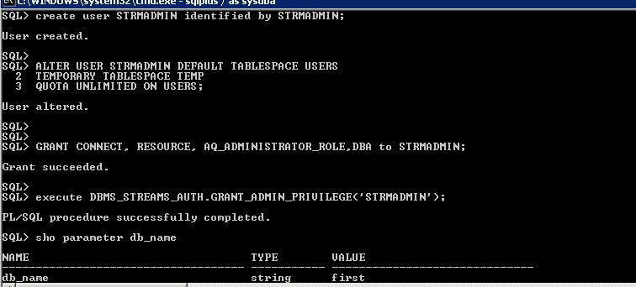

Next On target DB.
Screen Shot S.2.2. 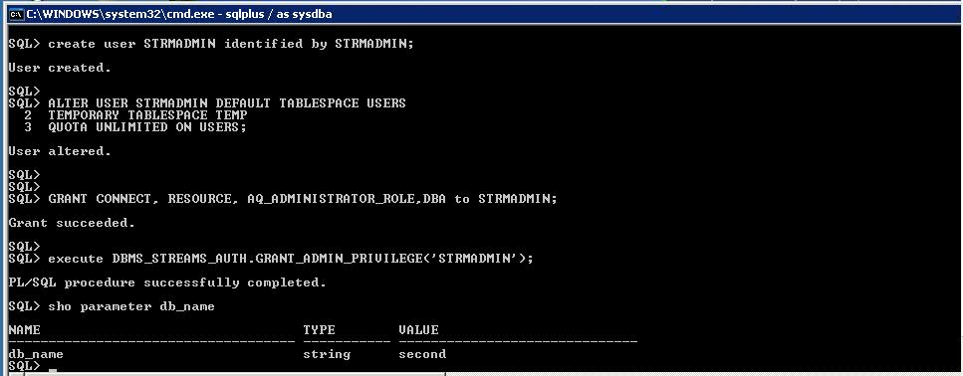

Step 3: Create the streams queue and the database links that will be used for propagation.

First Create two DB links on both databases.One is public database link created with sys schema and second link is private database link created with strmadmin schema and then proceed to create streams queue.

Script No 2:
Create two DB links on both databases.One is public database link created with sys schema and second link is private database link created with strmadmin schema and then proceed to create streams queue.

create public database link second using 'second';
conn strmadmin/STRMADMIN
create database link first connect to strmadmin identified by STRMADMIN;
create public database link second using 'second';
conn strmadmin/STRMADMIN
create database link second connect to strmadmin identified by STRMADMIN;
connect STRMADMIN/STRMADMIN
BEGIN
DBMS_STREAMS_ADM.SET_UP_QUEUE(
queue_table => 'STREAMS_QUEUE_TABLE',
queue_name => 'STREAMS_QUEUE',
queue_user => 'STRMADMIN');
END;

On source DB.
Screen Shot S.3.1
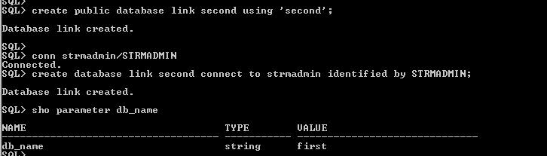

Second part: creation of Steams Queue on source .

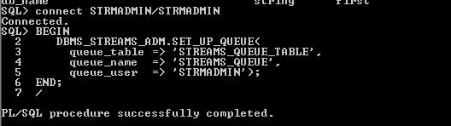

On target DB.

Screen Shot S.3.2
(Same script as Script No:2 but replace “second” with “first” in db links creation.)
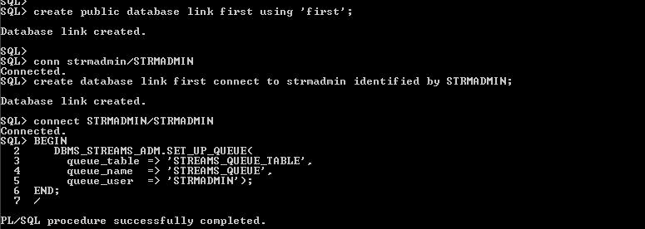
Step 4:
Add apply rules for the Schema at the destination database.

Script No:3.
connect STRMADMIN/STRMADMIN’
BEGIN
DBMS_STREAMS_ADM.ADD_SCHEMA_RULES(
schema_name => 'streams_user',
streams_type => 'APPLY ',
streams_name => 'STREAM_APPLY',
queue_name => 'STRMADMIN.STREAMS_QUEUE',
include_dml => true,
include_ddl => true,
source_database => 'first');
END;

Screen Shot S.4.1
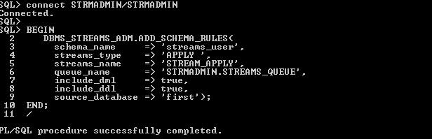

STEP 5:-
Add capture rules for the schema streams_queue at the source database.
Script No :4
connect STRMADMIN/STRMADMIN

BEGIN
DBMS_STREAMS_ADM.ADD_SCHEMA_RULES(
schema_name => 'streams_user',
streams_type => 'CAPTURE',
streams_name => 'STREAM_CAPTURE',
queue_name => 'STRMADMIN.STREAMS_QUEUE',
include_dml => true,
include_ddl => true,
source_database => 'first');
END;
Screen Shot S.5.1

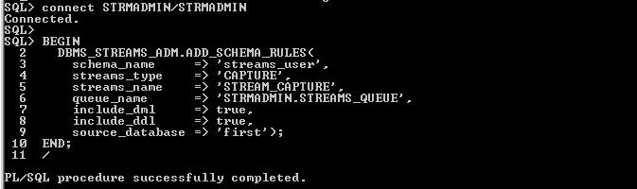

STEP 6.
Add propagation rules for the schema streams_user at the source database. This step will also create a propagation job to the destination database.

Script No:5
connect STRMADMIN/STRMADMIN
BEGIN
DBMS_STREAMS_ADM.ADD_SCHEMA_PROPAGATION_RULES(
schema_name => 'streams_user',
streams_name => 'STREAM_PROPAGATE',
source_queue_name => 'STRMADMIN.STREAMS_QUEUE',
destination_queue_name => 'STRMADMIN.STREAMS_QUEUE@second',
include_dml => true,
include_ddl => true,
source_database => 'first');
END;
/

Screen Shot S.6.1

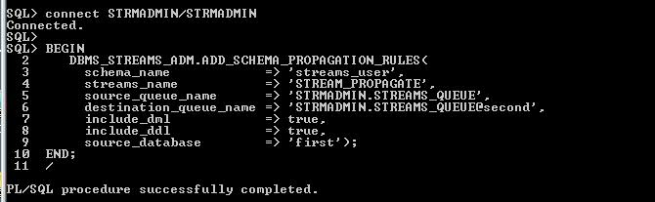

STEP 7.
Export, import using data pump with flash back SCN.

Screen Shot S.7.1
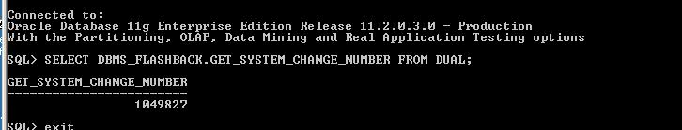

Script No:6
expdp strmadmin/STRMADMIN SCHEMAS=streams_user DIRECTORY=DIR DUMPFILE=streams_user_Schema.dmp logfile=streams_user_schema.log PARALLEL=4 FLASHBACK_SCN=1049827.

Screen Shot S.7.2
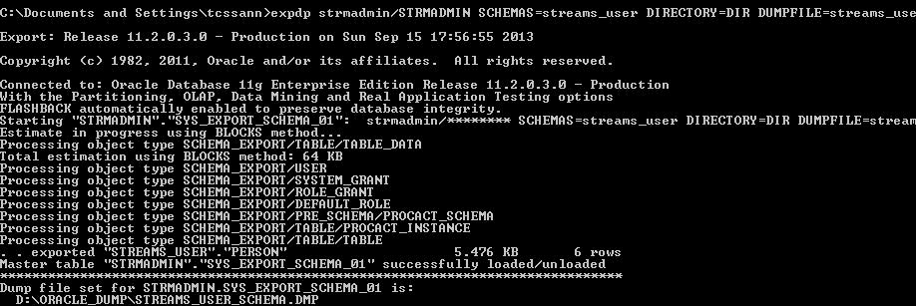

Import dump file on target DB.

Script No:7
impdp strmadmin/STRMADMIN SCHEMAS=streams_user DIRECTORY=DIR DUMPFILE=streams_user_Schema.dmp logfile=streams_user_schema.log PARALLEL=4.

Screen Shot S.7.3
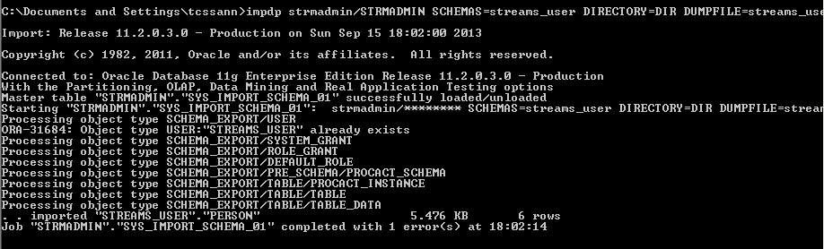
Continue to execute the below statements on target side.

Script NO:8

connect STRMADMIN/STRMADMIN
declare
v_scn number;
begin
v_scn := 1049827 ;
dbms_output.put_line('Scn : ' || v_scn);
dbms_apply_adm.set_schema_instantiation_scn(
source_schema_name => 'streams_user',
source_database_name => 'first',
instantiation_scn => v_scn,
recursive => true);
end;

Screen Shot S.7.4

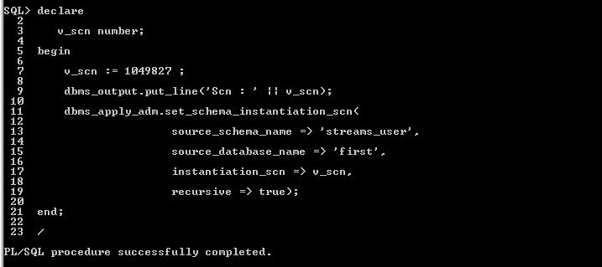

Script No:9

connect STRMADMIN/STRMADMIN
BEGIN
DBMS_APPLY_ADM.ALTER_APPLY(
apply_name => 'STREAM_APPLY',
apply_user => 'streams_user');
END;
/

BEGIN
DBMS_APPLY_ADM.SET_PARAMETER(
apply_name => 'STREAM_APPLY',
parameter => 'disable_on_error',
value => 'n');
END;
/
DECLARE
v_started number;
BEGIN
SELECT decode(status, 'ENABLED', 1, 0) INTO v_started
FROM DBA_APPLY WHERE APPLY_NAME = 'STREAM_APPLY';
if (v_started = 0) then
DBMS_APPLY_ADM.START_APPLY(apply_name => 'STREAM_APPLY');
end if;
END;

Screen Shot S.7.5

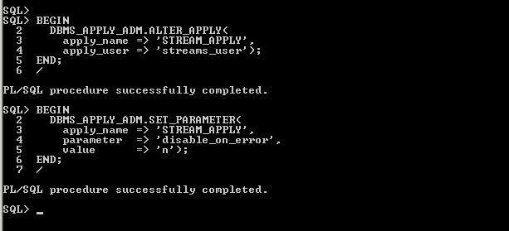

Screen Shot S.7.6

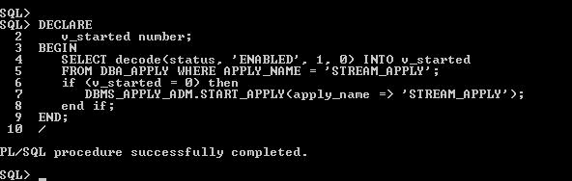

On Source DB .
Script No:10

connect STRMADMIN/STRMADMIN

BEGIN
DBMS_CAPTURE_ADM.ALTER_CAPTURE(
capture_name => 'STREAM_CAPTURE',
checkpoint_retention_time => 7);
END;/

begin
DBMS_CAPTURE_ADM.START_CAPTURE(capture_name => 'STREAM_CAPTURE');
end;

Screen Shot S.7.7

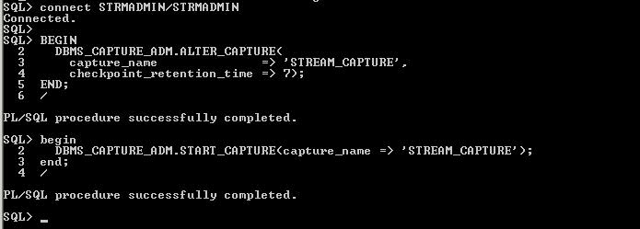
Checking streaming is happening or not from source to target db.Created 3 tables in source under streams_user schemas and destination has also 3 tables in streams_user schemas.Please find the pics.

On source:
Screen Shot S.7.8

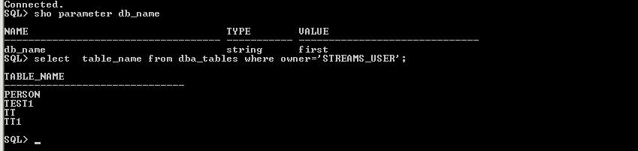

On target
Screen Shot S.7.9

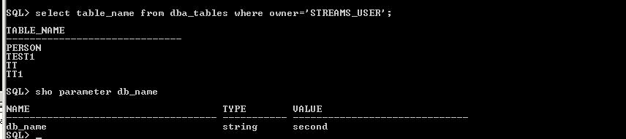

Streams Replication is working .

Problems faced.

Problem1 :Error “unable to allocate 588M for shared pool”.

Reason:Give Memory_target 250M and streaming is configured.But Streaming is not working in source and throwing error in alert log “unable to allocate 588M for shared pool”.

Solution : Increased memory_max_size value and DB is bounced .Executed command to start the capture process.
Streaming is working.

Problem 2:Different and strange OS errors in alert log file of target db.
Reason: Insatlled 32-bit oracle in 64-bit windows os and I am trying to setup streams.
Solution:Installed oracle 64-bit version and configured streams .

Referrences: Oracle Note: 301431.1.

