Step by Step Oracle 12c Grid Infrastructure (RAC) on Linux 64bit using Virtual Box

Category ; 12c Database ; GridInfrastructure

In this article we will install RAC and create RAC Database (Pluggable) using Latest release Oracle 12c on Oracle Enterprise Linux 64 bit.
First Download the required software with below links
Download the following software.
- Oracle Linux 6 (Use the latest spin eg. 6.4)
- VirtualBox (4.2.14)
- Oracle 12c Release 1 (12.1.0.1) Software (64 bit)
Hardware Requirements:-
- Minimum 4gb for each Virtual Machine
- Dual core with adequate CPU speed (2.5GHZ)
- Disk Space of 40-50 GB on your windows partition anywhere
Installation Phases
- Install Oracle Virtual Box
- Create Virtual Machine – oinfo12c-rac1
- Preparing the Guest OS for Oracle Installation (Oracle Prerequisites)
- Create Shared Disks for Grid Infrastructure
- Creating Partitions for shared Disk Storage
- Clone the Virtual Machine to second node – oinfo12c-rac2
- Stage the Oracle Software
- Modify the Virtual Machine – oinfo12c-rac2
- Test the machines readiness
- Install Grid Infrastructure
- Install Oracle RAC
- Create Database using DBCA

1. Install Virtual Box
Read it from here

2. Create Virtual Machine – oinfo12c-rac1
Start the virtualbox and Click on New and then the following screen will be displayed.
Input : Virtual Machine, oinfo12c-rac, Type as Linux and Version is Oracle, Click on Next
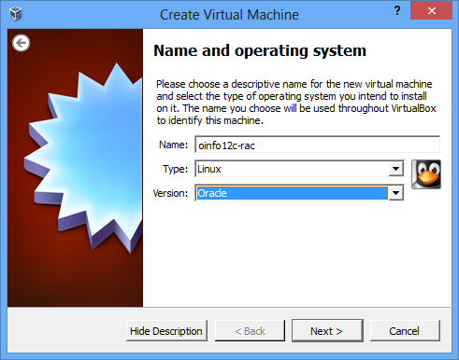
Select Memory , Ensure you have more than 3.5gb for each rac node, other wise your installation will not continue, Click on Next
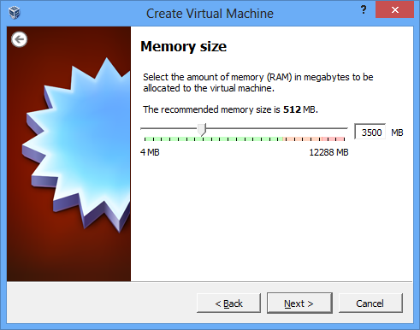
Create Virtual Disk section, Select Create Virtual Hard Drive and click on Create and then Select VDI (VirtualBox Disk Image)
If you want to use your Virtual Machine with VMware also , you can select VMDK option, click on next
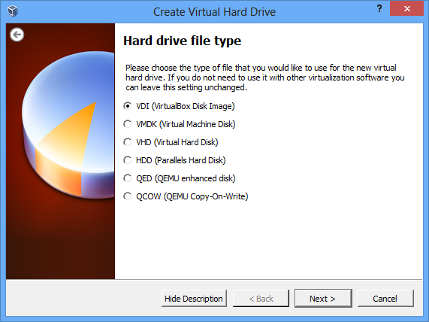
Select Dynamically Allocated option, then proceed
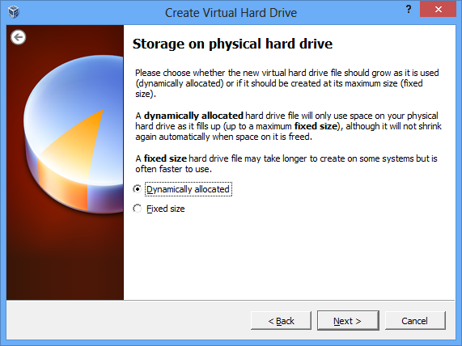
Choose the path for the Location of the Drives and the size of the Disk and then Click on Create
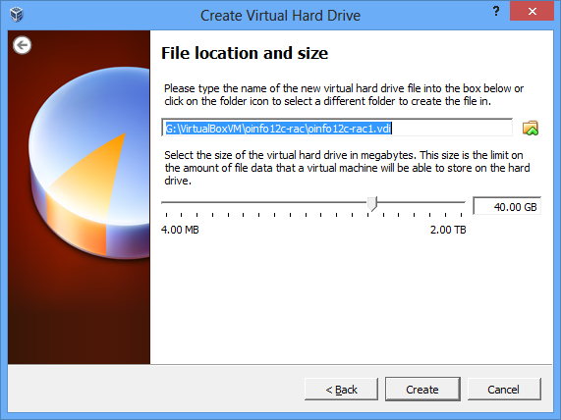
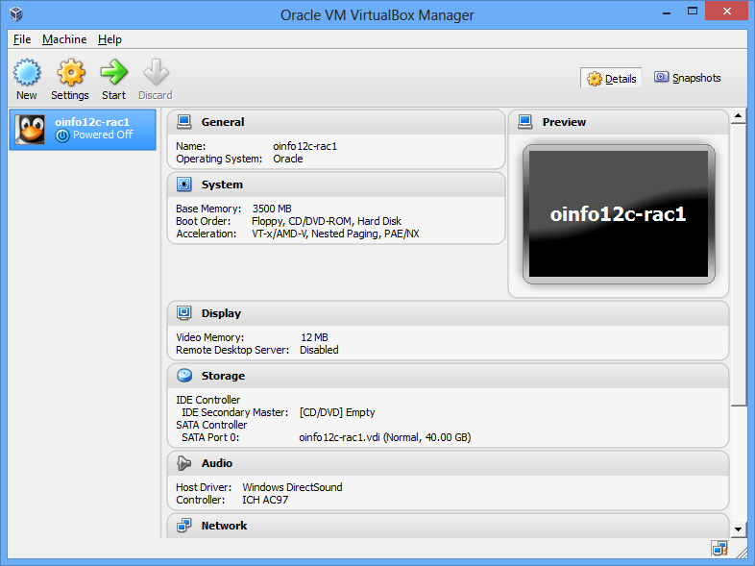
A VM has been ready, before proceed we need add additional Ethernet drives and Boot options for our Machine
Click on Settings and Add network devices for Cluster interconnect, Public Network and SCAN
For Adapter 1, Choose the following settings
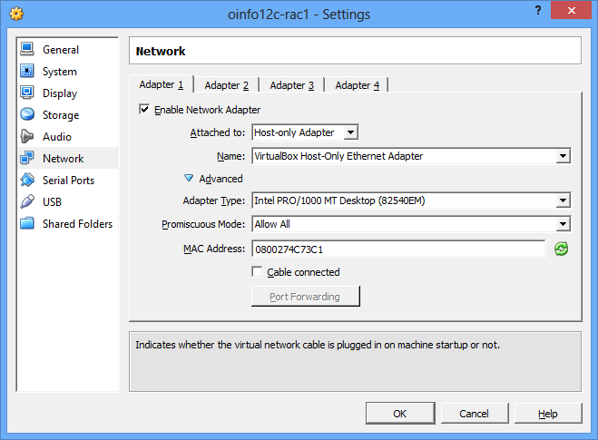
Click on Tab Adapter 2: and Choose following Options
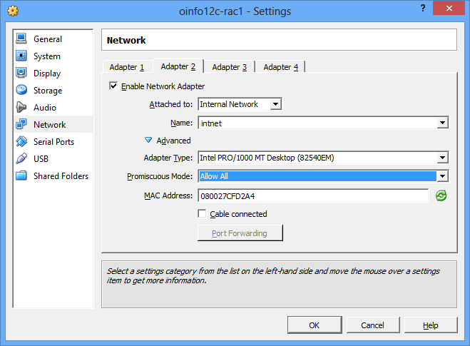
Click on Tab Adapter 3 and Choose followion options
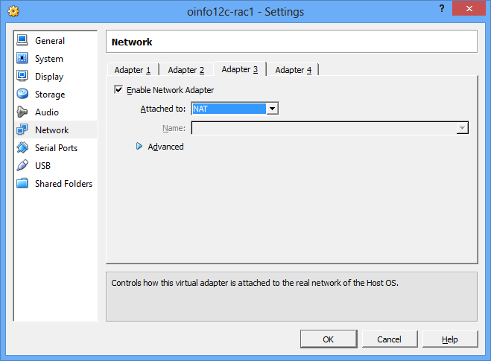
Ensure all adapters has Enabled Checkbox selected
Click on Storage and select as below, this is to choose the Linux ISO image for installation, I have ISO copied to my USB and I am selecting the same.
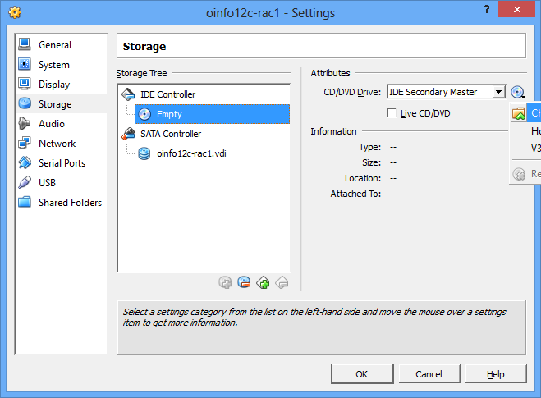
After selection the screen looks like below, click on Okay.
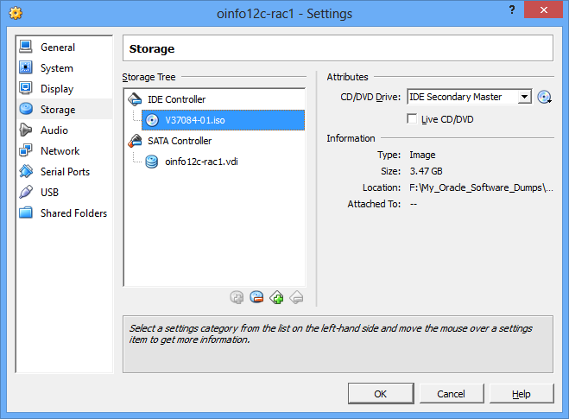
Now we are ready to install the linux on our first VM, Click on Start the top menu

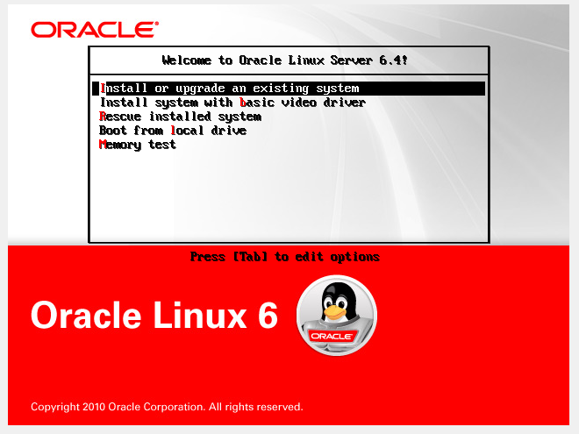
Select Install or Upgrade an existing System
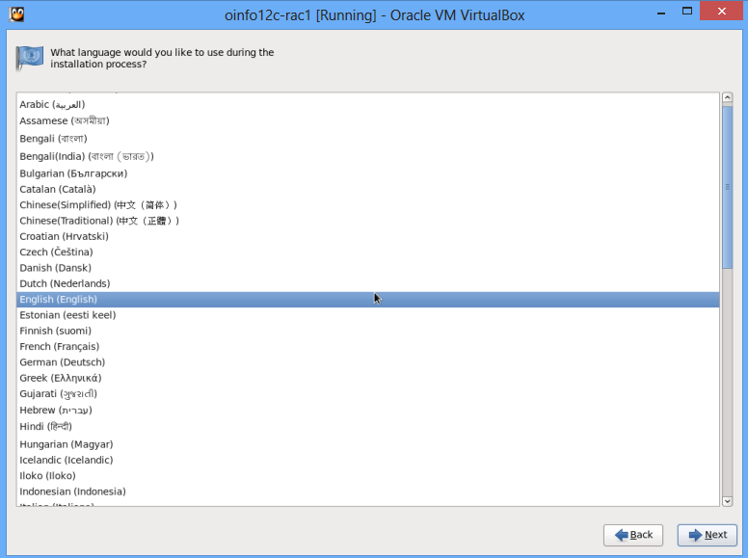
Select English and Click Next, Select Basic storage
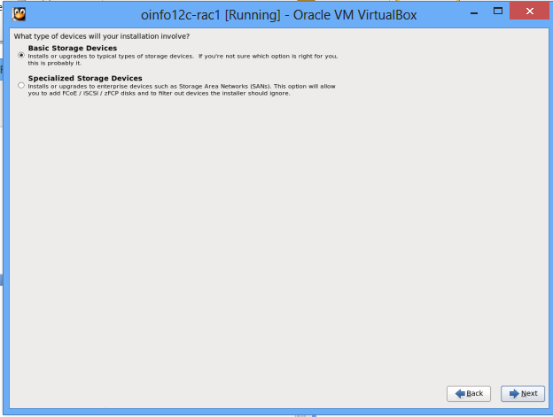
Installation will detect the storage attached to this machine and will erase any data if any in the disk we have added above.
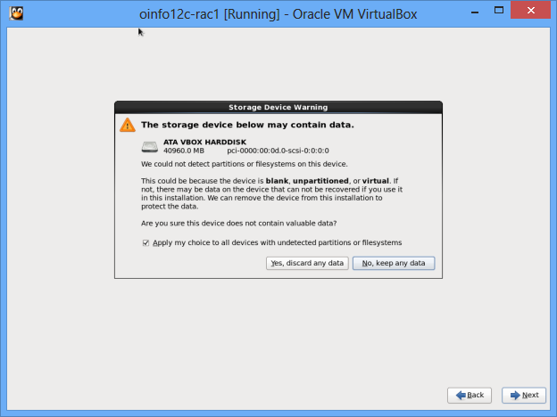
Click on Yes to remove the data and click on next, select hostname as oinfo-rac1.localdomain click on next
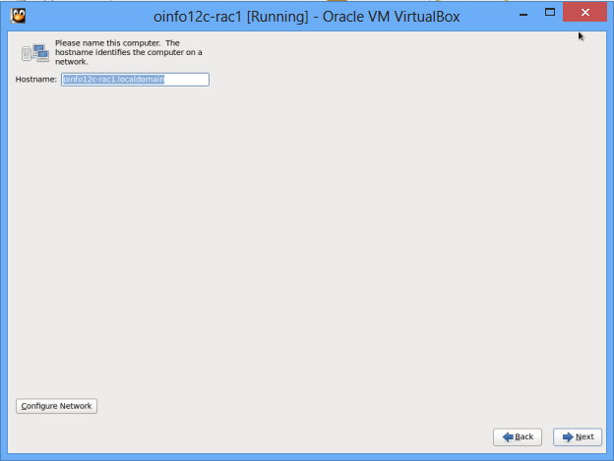
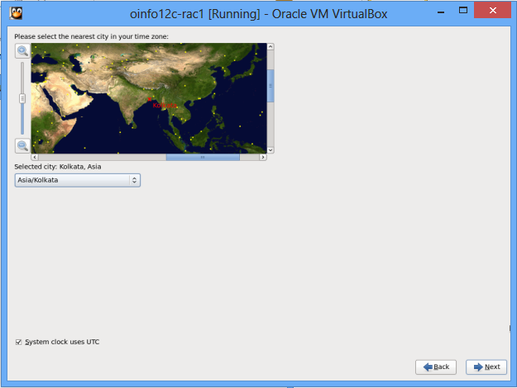
Input Root password
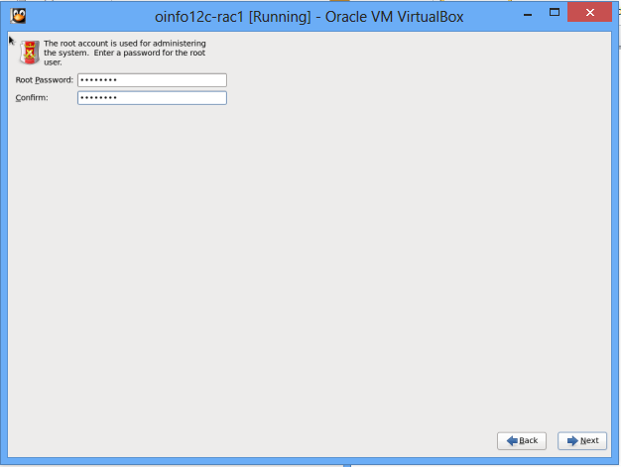
Use Replace option
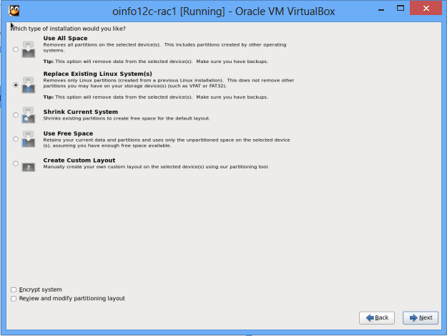
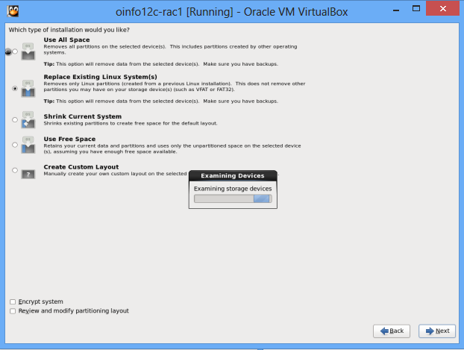

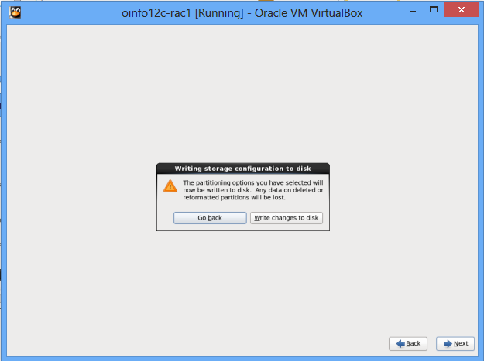
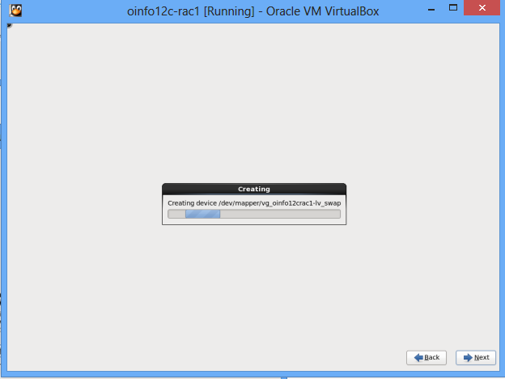
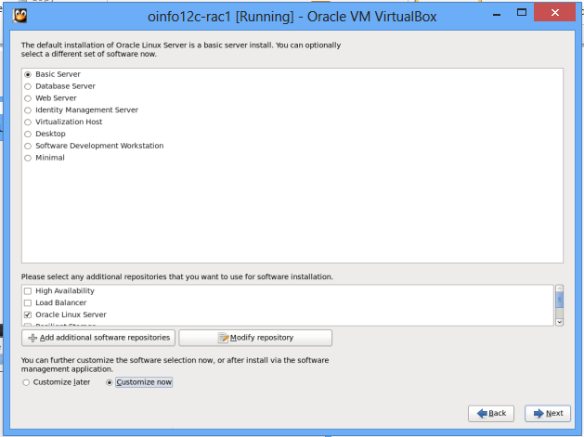
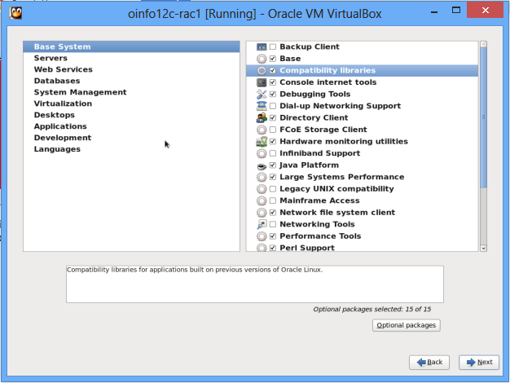
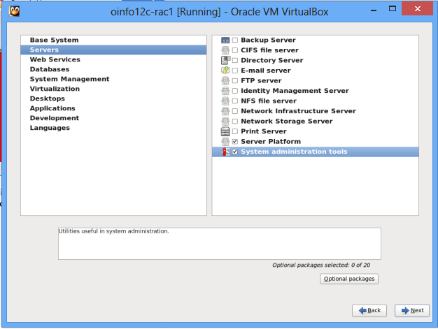
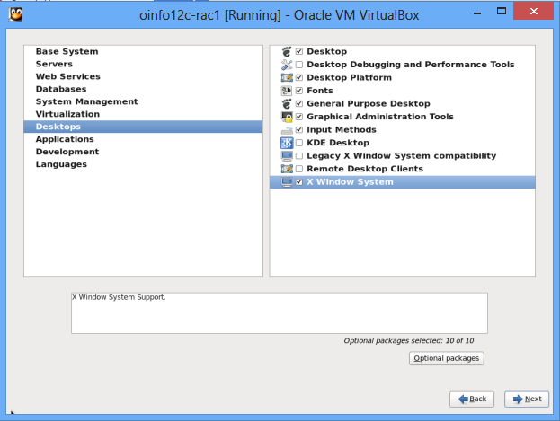
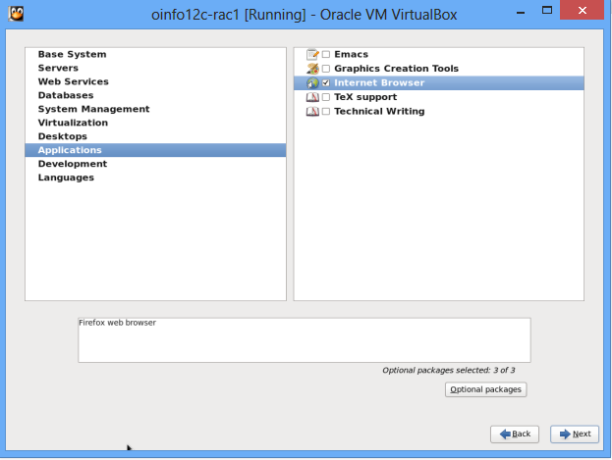
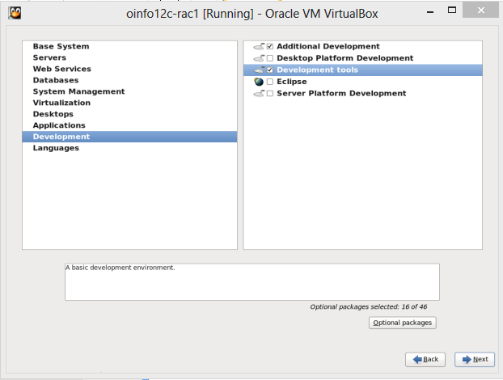

Click on Next will start Linux Installation

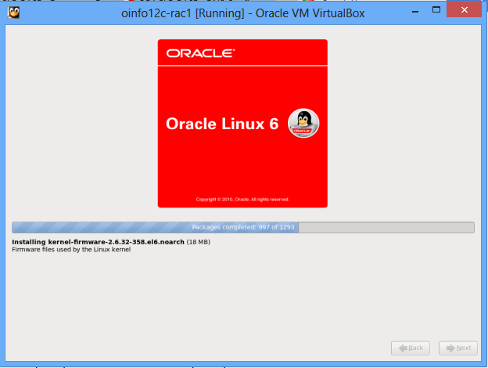
The system will reboot, once restarted perform the following Oracle Prerequisites

3. Perform Oracle Pre-requisites on the Newly created virtual Machine

Modif the /etc/sysctl.conf
fs.file-max = 6815744
kernel.sem = 250 32000 100 128
kernel.shmmni = 4096
kernel.shmall = 1073741824
kernel.shmmax = 4398046511104
net.core.rmem_default = 262144
net.core.rmem_max = 4194304
net.core.wmem_default = 262144
net.core.wmem_max = 1048576
fs.aio-max-nr = 1048576
net.ipv4.ip_local_port_range = 9000 65500

Load the newly amended values into kernel, without restart using /sbin/sysctl -p
Add the following lines to "/etc/security/limits.conf" file.

oracle soft nofile 1024
oracle hard nofile 65536
oracle soft nproc 2047
oracle hard nproc 16384
oracle soft stack 10240
oracle hard stack 32768

Load the RPMS's (64 and 32 bit) into the OS

rpm -q binutils compat-libcap1 compat-libstdc++-33 compat-libstdc++-33.i686 gcc gcc-c++ glibc glibc.i686 glibc-devel glibc-devel.i686 ksh libgcc libgcc.i686 \
libstdc++ libstdc++.i686 libstdc++-devel libstdc++-devel.i686 libaio libaio.i686 libaio-devel libaio-devel.i686 libXext libXext.i686 libXtst libXtst.i686 libX11 libX11.i686 \
libXau libXau.i686 libxcb libxcb.i686 libXi libXi.i686 make sysstat unixODBC unixODBC-devel

rpm -ivh binutils-2.20.51.0.2-5.36.el6.x86_64
rpm -ivh compat-libcap1-1.10-1.x86_64
rpm -ivh compat-libstdc++-33-3.2.3-69.el6.x86_64
rpm -ivh compat-libstdc++-33-3.2.3-69.el6.i686
rpm -ivh compat-libstdc++-33-3.2.3-69.el6.i686
rpm -ivh gcc-4.4.7-3.el6.x86_64
rpm -ivh gcc-c++-4.4.7-3.el6.x86_64
rpm -ivh glibc-2.12-1.107.el6.x86_64
rpm -ivh glibc-2.12-1.107.el6.i686
rpm -ivh glibc-2.12-1.107.el6.i686
rpm -ivh glibc-devel-2.12-1.107.el6.x86_64
rpm -ivh glibc-devel-2.12-1.107.el6.i686
rpm -ivh glibc-devel-2.12-1.107.el6.i686
rpm -ivh ksh-20100621-19.el6.x86_64
rpm -ivh libgcc-4.4.7-3.el6.x86_64
rpm -ivh libgcc-4.4.7-3.el6.i686
rpm -ivh libgcc-4.4.7-3.el6.i686
rpm -ivh libstdc++-4.4.7-3.el6.x86_64
rpm -ivh libstdc++-4.4.7-3.el6.i686
rpm -ivh libstdc++-4.4.7-3.el6.i686
rpm -ivh libstdc++-devel-4.4.7-3.el6.x86_64
rpm -ivh libstdc++-devel-4.4.7-3.el6.i686
rpm -ivh libstdc++-devel-4.4.7-3.el6.i686
rpm -ivh libaio-0.3.107-10.el6.x86_64
rpm -ivh libaio-0.3.107-10.el6.i686
rpm -ivh libaio-0.3.107-10.el6.i686
rpm -ivh libaio-devel-0.3.107-10.el6.i686
rpm -ivh libaio-devel-0.3.107-10.el6.x86_64
rpm -ivh libaio-devel-0.3.107-10.el6.i686
rpm -ivh libXext-1.3.1-2.el6.x86_64
rpm -ivh libXext-1.3.1-2.el6.i686
rpm -ivh libXext-1.3.1-2.el6.i686
rpm -ivh libXtst-1.2.1-2.el6.x86_64
rpm -ivh libXtst-1.2.1-2.el6.i686
rpm -ivh libXtst-1.2.1-2.el6.i686
rpm -ivh libX11-1.5.0-4.el6.x86_64
rpm -ivh libX11-1.5.0-4.el6.i686
rpm -ivh libX11-1.5.0-4.el6.i686
rpm -ivh libXau-1.0.6-4.el6.x86_64
rpm -ivh libXau-1.0.6-4.el6.i686
rpm -ivh libXau-1.0.6-4.el6.i686
rpm -ivh libxcb-1.8.1-1.el6.x86_64
rpm -ivh libxcb-1.8.1-1.el6.i686
rpm -ivh libxcb-1.8.1-1.el6.i686
rpm -ivh libXi-1.6.1-3.el6.x86_64
rpm -ivh libXi-1.6.1-3.el6.i686
rpm -ivh libXi-1.6.1-3.el6.i686
rpm -ivh make-3.81-20.el6.x86_64
rpm -ivh sysstat-9.0.4-20.el6.x86_64
rpm -ivh unixODBC-2.2.14-12.el6_3.x86_64
rpm -ivh unixODBC-devel-2.2.14-12.el6_3.x86_64

Or use rpm –ivh pkgname

Create New Users and Groups

groupadd -g 60321 oinstall
groupadd -g 60322 dba
groupadd -g 60323 oper
groupadd -g 60324 backupdba
groupadd -g 60325 dgdba
groupadd -g 60326 kmdba
groupadd -g 60327 asmdba
groupadd -g 60328 asmoper
groupadd -g 60329 asmadmin
groupadd –g 60330 oragrid

Create Oracle and add groups to oracle accordingly

useradd -u 60321 -g oinstall -G dba,oper,backupdba,dgdba,kmdba,asmdba,asmoper,asmadmin,oragrid oracle
passwd oracle

Add the following entries to "/etc/hosts"

127.0.0.1 localhost.localdomain localhost
192.168.56.101 oinfo12c-rac1.localdomain oinfo12c-rac1
192.168.56.102 oinfo12c-rac2.localdomain oinfo12c-rac2
192.168.1.101 oinfo12c-rac1-priv.localdomain oinfo12c-rac1-priv
192.168.1.102 oinfo12c-rac2-priv.localdomain oinfo12c-rac2-priv
192.168.56.103 oinfo12c-rac1-vip.localdomain oinfo12c-rac1-vip
192.168.56.104 oinfo12c-rac2-vip.localdomain oinfo12c-rac2-vip
#192.168.56.105 oinfo12c-scan.localdomain oinfo12c-scan
#192.168.56.106 oinfo12c-scan.localdomain oinfo12c-scan
#192.168.56.107 oinfo12c-scan.localdomain oinfo12c-scan

The reason to comment the scan IP is that from 11Gr2 (11.2.0.2) scan IP in /etc/hosts will not work, either DNS has to be used or someother tools like dnsmasq or BIND should be used. For this Article purpose we will use dnsmasq,

Courtesy : oracle-base.com

Install DNSmasq package

The Dnsmasq service is installed from a Yum repository using the following command.

# yum install dnsmasq

Turn on the Dnsmasq server and make sure it starts automatically on reboot.

# service dnsmasq start
# chkconfig dnsmasq on

Edit the /etc/resolv.conf

search localdomain
nameserver 192.168.56.101

The service can be stopped, started and restarted using the following commands.

# service dnsmasq stop
# service dnsmasq start
# service dnsmasq restart

Note: Disable Firewall

Verify the scan using nslookup, should return all three IP's

[root@oinfo12c-rac1 Packages]# nslookup oinfo12c-scan.localdomain
Server: 192.168.56.101
Address: 192.168.56.101#53

Name: oinfo12c-scan.localdomain
Address: 192.168.56.107
Name: oinfo12c-scan.localdomain
Address: 192.168.56.105
Name: oinfo12c-scan.localdomain
Address: 192.168.56.106

[root@oinfo12c-rac1 Packages]#

Change Linux SE to permissive (Linux 6 installation does not offer this change) by editing the "/etc/selinux/config" file,

SELINUX=permissive

Disable Firewall

# service iptables stop
# chkconfig iptables off

Not to use NTP and make CTSSD works for you, you need to disable the NTP as below

# service ntpd stop
Shutting down ntpd: [ OK ]
# chkconfig ntpd off
# mv /etc/ntp.conf /etc/ntp.conf.orig
# rm /var/run/ntpd.pid

But if you want to use NTP and sycn time with your time server , you must add the "-x" option into the following line in the "/etc/sysconfig/ntpd" file.

OPTIONS="-x -u ntp:ntp -p /var/run/ntpd.pid"

Then restart NTP.

# service ntpd restart

Create Directories

mkdir -p /u01/app/12.1.0.1/grid
mkdir -p /u01/app/oracle/product/12.1.0.1/db_1
chown -R oracle:oinstall /u01
chmod -R 775 /u01/

Login with oracle and create a .bash_profile in /home/oracle/

export TMP=/tmp
export TMPDIR=$TMP
export ORACLE_HOSTNAME=oinfo12c-rac1.localdomain
export ORACLE_UNQNAME=RACDB
export ORACLE_BASE=/u01/app/oracle
export GRID_HOME=/u01/app/12.1.0.1/grid
export DB_HOME=$ORACLE_BASE/product/12.1.0.1/db_1
export ORACLE_HOME=$DB_HOME
export ORACLE_SID=RACDB1
export ORACLE_TERM=xterm
export BASE_PATH=/usr/sbin:$PATH
export PATH=$ORACLE_HOME/bin:$BASE_PATH

export LD_LIBRARY_PATH=$ORACLE_HOME/lib:/lib:/usr/lib
export CLASSPATH=$ORACLE_HOME/JRE:$ORACLE_HOME/jlib:$ORACLE_HOME/rdbms/jlib

Install Guest Additions from VIrtualBox Devices Install Guest Additions this will mount and package in /media, if you have any other mount in /media, dismount and eject it.
Note: Without this the shared storage will not work

Restart the oinfo12c-rac1

# shutdown –r now

Create Shared Storage path for RAC Shared storage

Go to Setting for oinfo12c-rac1 and then click on shared storage and then create a directory , I have created a directory in my windows machine
G:virtualboxvmoinfo12c-racshared
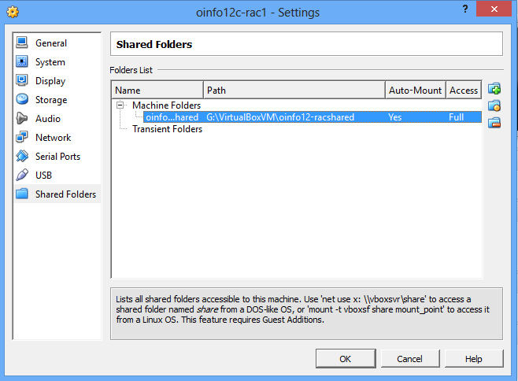

Create the directory in windows for Node 2 and clone the harddisk. So my directory structure is like

Host: oinfo12c-rac1 files will be in oinfo12c-rac1 folder
Host: oinfo12c-rac1 files will be in oinfo12c-rac1 folder
Shared storage will be at oinfor12c-racshared folder
Screenshot as below

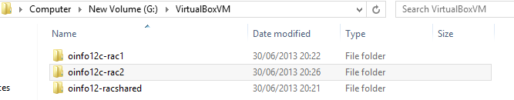

Shutdown the machine

4. Create Shared folders for RAC

Create the disks and associate them with VirtualBox as virtual media.

VBoxManage createhd --filename G:\VirtualBoxVM\oinfo12c-shared\asm1.vdi --size 5120 --format VDI --variant Fixed
VBoxManage createhd --filename G:\VirtualBoxVM\oinfo12c-shared\asm2.vdi --size 5120 --format VDI --variant Fixed
VBoxManage createhd --filename G:\VirtualBoxVM\oinfo12c-shared\asm3.vdi --size 5120 --format VDI --variant Fixed
VBoxManage createhd --filename G:\VirtualBoxVM\oinfo12c-shared\asm4.vdi --size 5120 --format VDI --variant Fixed
Sample output:-
C:\Program Files\Oracle\VirtualBox>VBoxManage createhd --filename G:\VirtualBoxVM\oinfo12c-shared\asm1.vdi --size 5120 -
-format VDI --variant Fixed
0%...10%...20%...30%...40%...50%...60%...70%...80%...90%...100%
Disk image created. UUID: 199e7910-bc1a-40d7-91fb-226326537506

C:\Program Files\Oracle\VirtualBox>VBoxManage createhd --filename G:\VirtualBoxVM\oinfo12c-shared\asm2.vdi --size 5120 -
-format VDI --variant Fixed
0%...10%...20%...30%...40%...50%...60%...70%...80%...90%...100%
Disk image created. UUID: db15a49a-1609-4a16-bea9-24859449fdf8

C:\Program Files\Oracle\VirtualBox>VBoxManage createhd --filename G:\VirtualBoxVM\oinfo12c-shared\asm3.vdi --size 5120 -
-format VDI --variant Fixed
0%...10%...20%...30%...40%...50%...60%...70%...80%...90%...100%
Disk image created. UUID: 13e177f9-60ba-47b7-846b-0522b3ae0080

C:\Program Files\Oracle\VirtualBox>VBoxManage createhd --filename G:\VirtualBoxVM\oinfo12c-shared\asm4.vdi --size 5120 -
-format VDI --variant Fixed
0%...10%...20%...30%...40%...50%...60%...70%...80%...90%...100%
Disk image created. UUID: 16268d1b-6087-4408-9211-f1bbf039d6e3

Connect them to the VM.
VBoxManage storageattach oinfo12c-rac1 --storagectl "SATA Controller" --port 1 --device 0 --type hdd --medium G:\VirtualBoxVM\oinfo12c-shared\asm1.vdi --mtype shareable
VBoxManage storageattach oinfo12c-rac1 --storagectl "SATA Controller" --port 2 --device 0 --type hdd --medium G:\VirtualBoxVM\oinfo12c-shared\asm2.vdi --mtype shareable
VBoxManage storageattach oinfo12c-rac1 --storagectl "SATA Controller" --port 3 --device 0 --type hdd --medium G:\VirtualBoxVM\oinfo12c-shared\asm3.vdi --mtype shareable
VBoxManage storageattach oinfo12c-rac1 --storagectl "SATA Controller" --port 4 --device 0 --type hdd --medium G:\VirtualBoxVM\oinfo12c-shared\asm4.vdi --mtype shareable

Make shareable.
VBoxManage modifyhd G:\VirtualBoxVM\oinfo12c-shared\asm1.vdi --type shareable
VBoxManage modifyhd G:\VirtualBoxVM\oinfo12c-shared\asm2.vdi --type shareable
VBoxManage modifyhd G:\VirtualBoxVM\oinfo12c-shared\asm3.vdi --type shareable
VBoxManage modifyhd G:\VirtualBoxVM\oinfo12c-shared\asm4.vdi --type shareable
After addition the storage looks like below
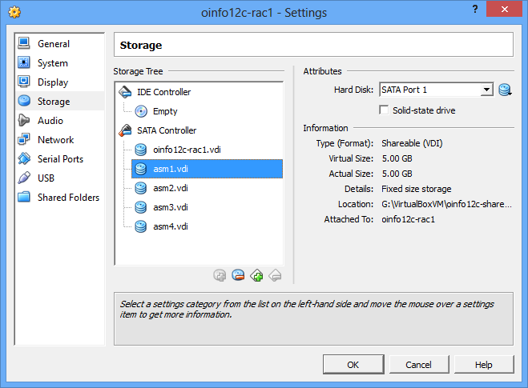
Start the Virtual Machine Node 1 and then proceed to add disks

For this Shared storage I will be using ASM LIB, in order to get the asmlib used, we will need the correct ASM Library drivers . Create the partitions to the shared disks, I have got four partitions from sdb,sdc,sdd,sde,

5. Creating Partitions for shared Disk Storage

Create them as appropriate, Replace * with letter above and repeat for all 4 disks

[root@oinfo12c-rac1 ~]# fdisk /dev/sd*
Device contains neither a valid DOS partition table, nor Sun, SGI or OSF disklabel
Building a new DOS disklabel with disk identifier 0x299c5f14.
Changes will remain in memory only, until you decide to write them.
After that, of course, the previous content won't be recoverable.

Warning: invalid flag 0x0000 of partition table 4 will be corrected by w(rite)

WARNING: DOS-compatible mode is deprecated. It's strongly recommended to
switch off the mode (command 'c') and change display units to
sectors (command 'u').

Command (m for help): n
Command action
e extended
p primary partition (1-4)
p
Partition number (1-4): 1
First cylinder (1-652, default 1):
Using default value 1
Last cylinder, +cylinders or +size{K,M,G} (1-652, default 652):
Using default value 652

Command (m for help): w
The partition table has been altered!

Calling ioctl() to re-read partition table.
Syncing disks.
[root@oinfo12c-rac1 ~]#

Download ASM Lib support and package from here for your kernel Type,

Please note from Linux 6 onwards the the ASMlib driver is included in the UEK kernel

[root@oinfo12c-rac1 oracle]# uname -a
Linux oinfo12c-rac1.localdomain 2.6.39-400.17.1.el6uek.x86_64 #1 SMP Fri Feb 22 18:16:18 PST 2013 x86_64 x86_64 x86_64 GNU/Linux

So I assume asmlib driver is already installed,the rest two I have done now

[root@oinfo12c-rac1 oracle]# rpm -ivh oracleasmlib-2.0.4-1.el5.x86_64.rpm oracleasm-support-2.1.8-1.el5.x86_64.rpm
warning: oracleasmlib-2.0.4-1.el5.x86_64.rpm: Header V3 DSA/SHA1 Signature, key ID 1e5e0159: NOKEY
Preparing... ########################################### [100%]
1:oracleasm-support ########################################### [ 50%]
2:oracleasmlib ########################################### [100%]
[root@oinfo12c-rac1 oracle]#

Configure the ASMLIB
[root@oinfo12c-rac1 oracle]# oracleasm configure -i
Configuring the Oracle ASM library driver.

This will configure the on-boot properties of the Oracle ASM library
driver. The following questions will determine whether the driver is
loaded on boot and what permissions it will have. The current values
will be shown in brackets ('[]'). Hitting <ENTER> without typing an
answer will keep that current value. Ctrl-C will abort.

Default user to own the driver interface []: oracle
Default group to own the driver interface []: oinstall
Start Oracle ASM library driver on boot (y/n) [n]: y
Scan for Oracle ASM disks on boot (y/n) [y]: y
Writing Oracle ASM library driver configuration: done

[root@oinfo12c-rac1 oracle]# oracleasm init
Creating /dev/oracleasm mount point: /dev/oracleasm
Loading module "oracleasm": oracleasm
Configuring "oracleasm" to use device physical block size
Mounting ASMlib driver filesystem: /dev/oracleasm

Create/Stamp the Disks with ASMLib and label them with Disk names
[root@oinfo12c-rac1 oracle]# oracleasm createdisk DISK1 /dev/sdb1
Writing disk header: done
Instantiating disk: done
[root@oinfo12c-rac1 oracle]# oracleasm createdisk DISK2 /dev/sdc1
Writing disk header: done
Instantiating disk: done
[root@oinfo12c-rac1 oracle]# oracleasm createdisk DISK4 /dev/sdd1
Writing disk header: done
Instantiating disk: done
[root@oinfo12c-rac1 oracle]# oracleasm createdisk DISK3 /dev/sde1
Writing disk header: done
Instantiating disk: done
Scan the Disks
[root@oinfo12c-rac1 oracle]# oracleasm scandisks
Reloading disk partitions: done
Cleaning any stale ASM disks...
Scanning system for ASM disks...
List the Disks
[root@oinfo12c-rac1 oracle]# oracleasm listdisks
DISK1
DISK2
DISK3
DISK4
[root@oinfo12c-rac1 oracle]#

Shutdown the Node

6. Clone the Virtual Machine & Prepare second node

Shutdown the node 1
#Shutdown -h now
Clone the harddisk of node1 to node2, Select the folder path where you have created the empty folder above in my case it is
In the host operating system command prompt
VBoxManage clonehd G:\VirtualBoxVM\oinfo12c-rac1\oinfo12c-rac1.vdi G:\VirtualBoxVM\oinfo12c-rac2\oinfo12c-rac2.vdi
A harddisk will now be cloned to G:\VirtualBoxVM\oinfo12c-rac2\oinfo12c-rac2.vdi
Create a New Virtual Machine as follows
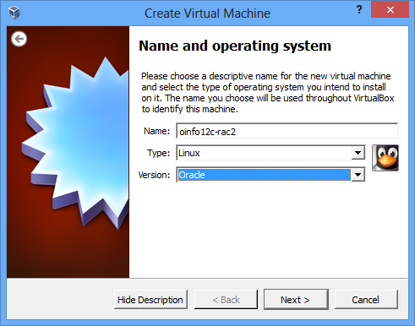

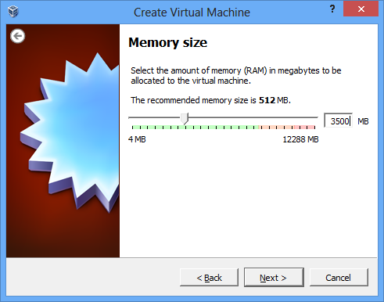
Here select the disk that has cloned just before
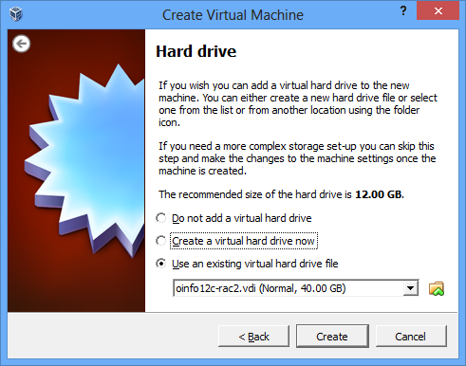

Cick on settings for node 2 and add network adapters and also the shared storages
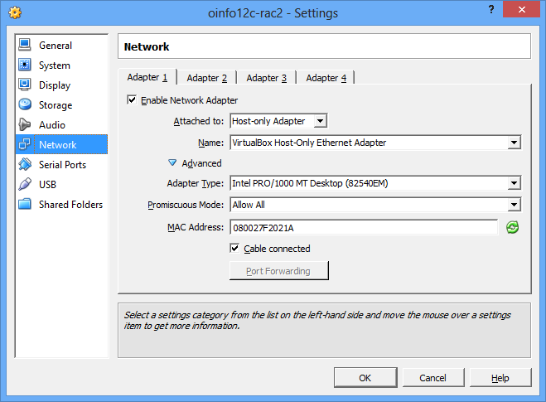
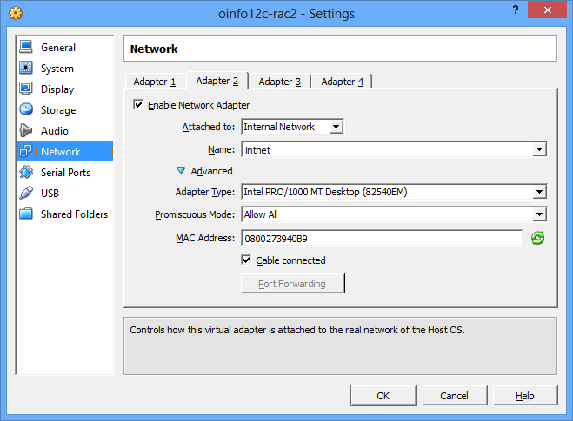
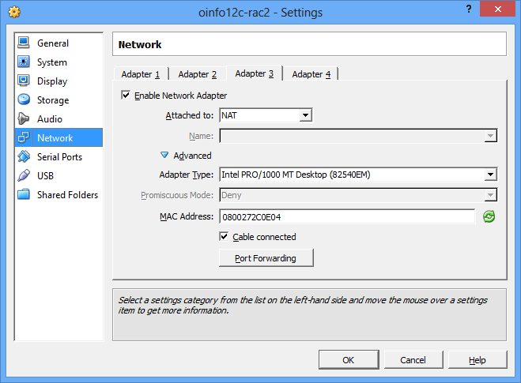
Add shared storages to Node 2
VBoxManage storageattach oinfo12c-rac2 --storagectl "SATA Controller" --port 1 --device 0 --type hdd --medium G:\VirtualBoxVM\oinfo12c-shared\asm1.vdi --mtype shareable
VBoxManage storageattach oinfo12c-rac2 --storagectl "SATA Controller" --port 2 --device 0 --type hdd --medium G:\VirtualBoxVM\oinfo12c-shared\asm2.vdi --mtype shareable
VBoxManage storageattach oinfo12c-rac2 --storagectl "SATA Controller" --port 3 --device 0 --type hdd --medium G:\VirtualBoxVM\oinfo12c-shared\asm3.vdi --mtype shareable
VBoxManage storageattach oinfo12c-rac2 --storagectl "SATA Controller" --port 4 --device 0 --type hdd --medium G:\VirtualBoxVM\oinfo12c-shared\asm4.vdi --mtype shareable

Finally the node 2 looks like

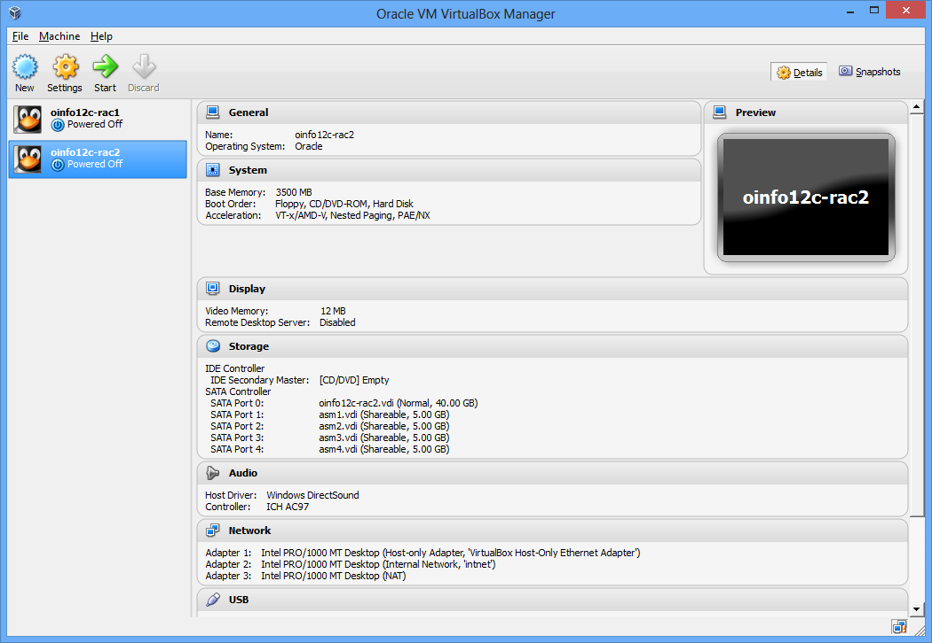

Startup the Node 2 by clicking start , once started do the following
Change Network configuration for Node 2
Ensure you delete all network interfaces and add them again and also delete any files that has .bak in /etc/sysconfig/network-scripts/ifcfg*.bak
Go to System - Preferences - Network connections and delete all three eth interfaces and them again
Once done do a network restart
#service network restart
After adding eth interfaces, Make the configuration as follows:-
eth0: IP=192.168.56.102, Subnet=255.255.255.0, Gateway=192.168.56.1, DNS=192.168.56.1, Search=localdomain (Connect Automatically)
eth1: IP=192.168.1.102, Subnet=255.255.255.0, Gateway=<blank>, DNS=<blank>, Search=<blank> (Connect Automatically)
eth3: DHCP (*Not* Connect Automatically)
Change the hostname in /etc/sysconfig/network
NETWORKING=yes
HOSTNAME=oinfo12c-rac2.localdomain
Change the /home/oracle/.bash_profile
export ORACLE_SID=rac12cdb2
export ORACLE_HOSTNAME=oinfo12c-rac2.localdomain

Now restart the oinfo12c-rac2 and start the oinfo12c-rac1, once they started do a network reachable test and also verify asm disks availability

7. Installing Grid Infrastructure/Clusterware

./runInstaller
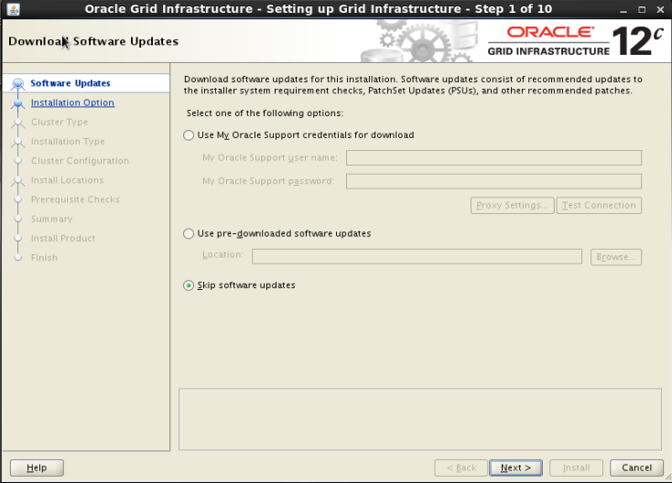

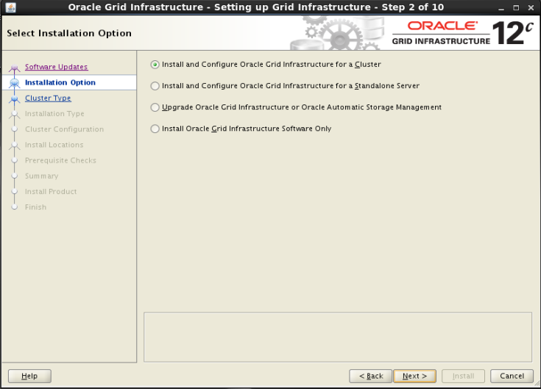

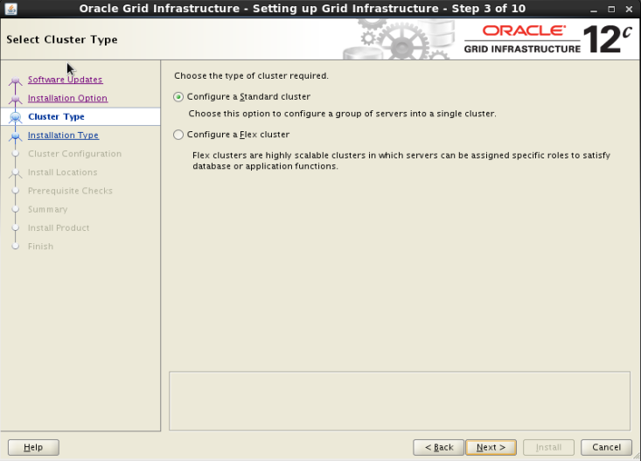

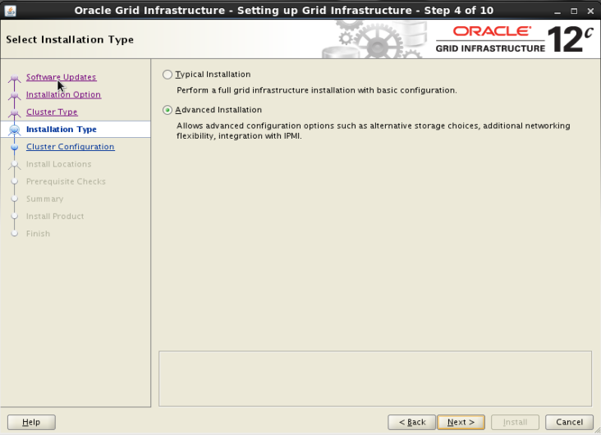

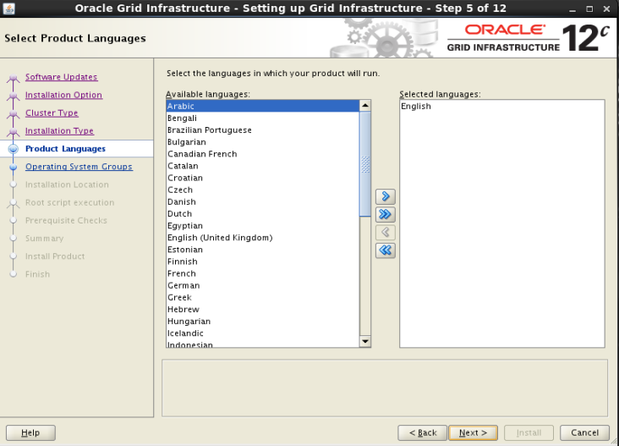

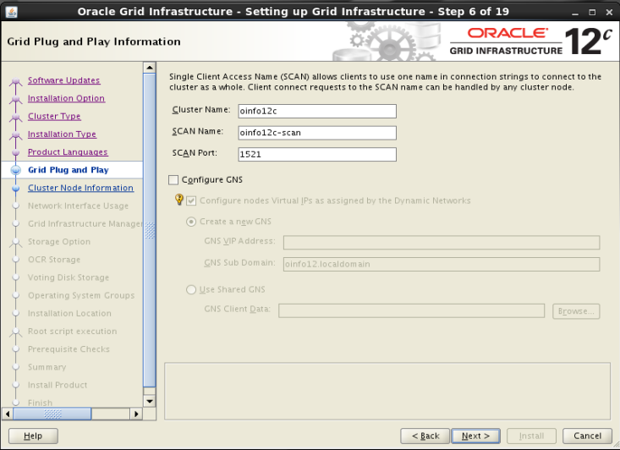

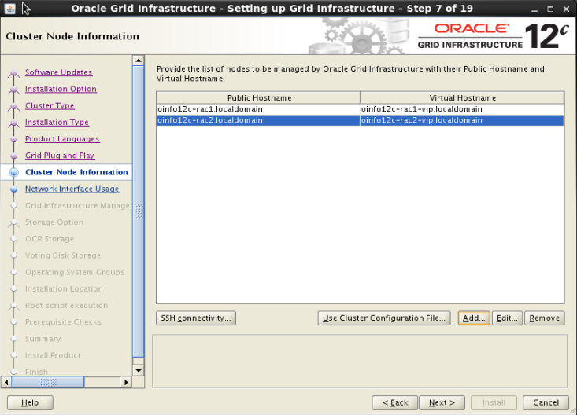

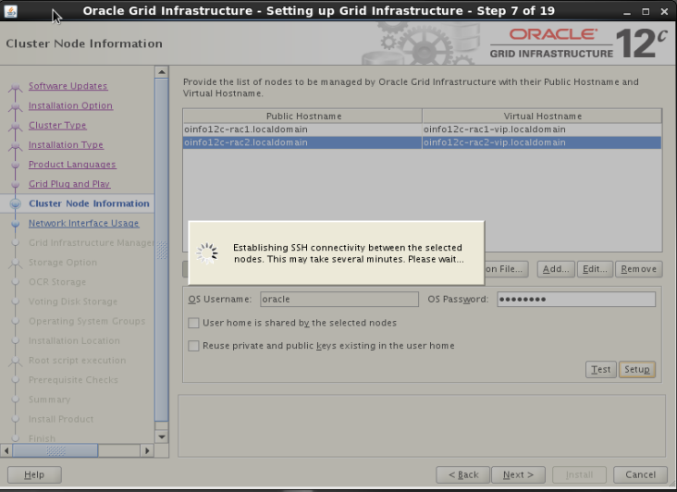

Do not select ASM & Private if you are not planning to USE FlexASM (this is new concept will discuss in ASM section), this will fail in next

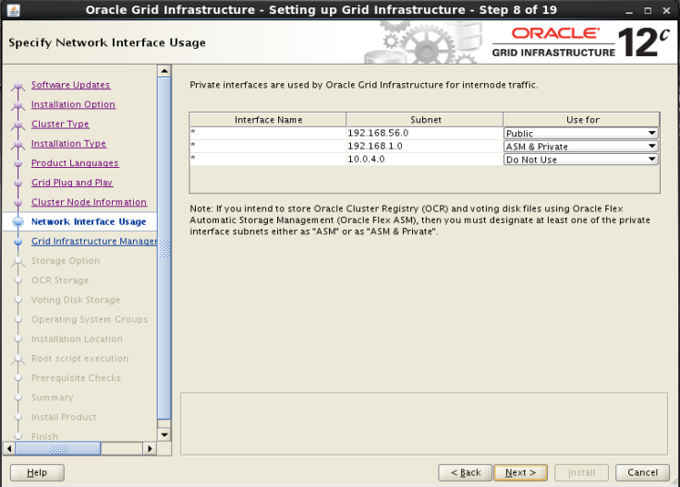

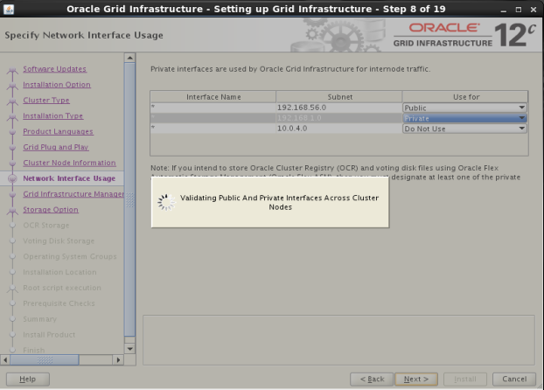

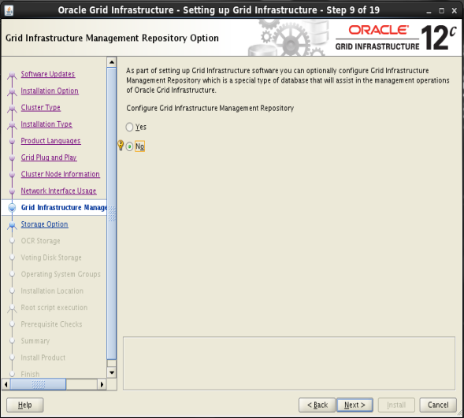

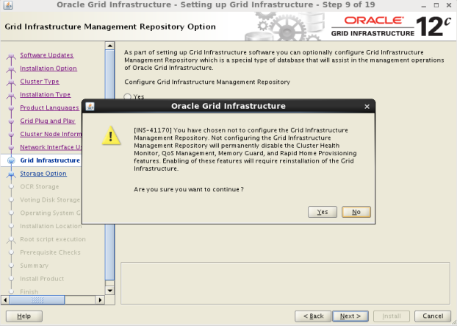

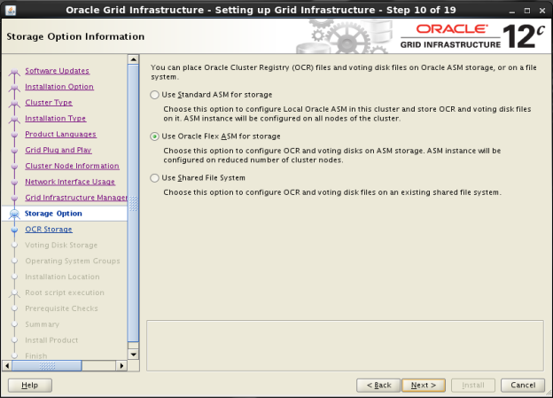

As you saw the installation is telling that For using standard asm storage (not flexASM) the clusterinterconnect should not marked as ASM, (as above I did and went back and changed to Private interconnect only)

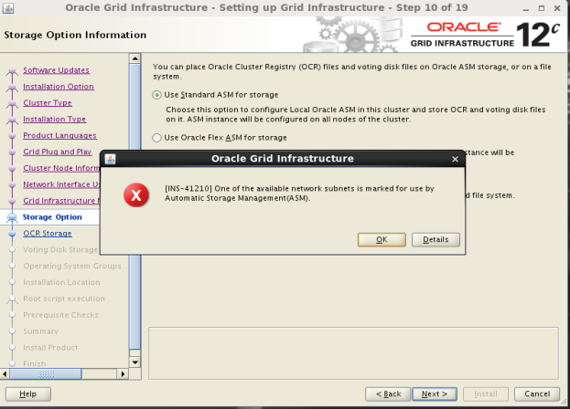

Now, I have modified the cluster interconnect to Private (only) in previous screens and this errors go away.

The next screen shows, Disk group name and the disks, I have selected all disks and also ensure to change the Disk Discovery Path to “/dev/oracleasm/disks/*”

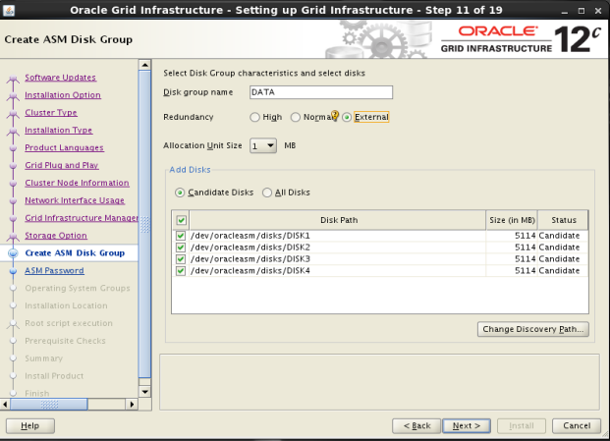

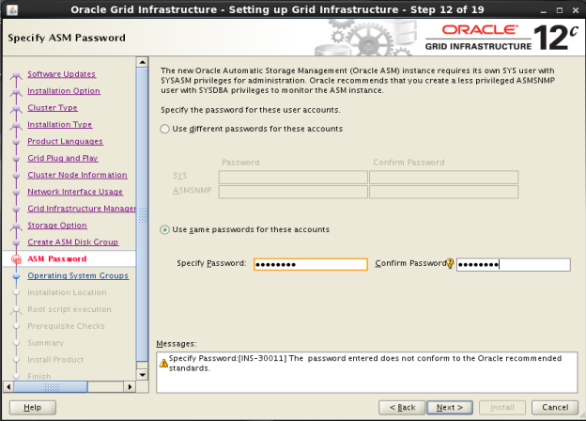

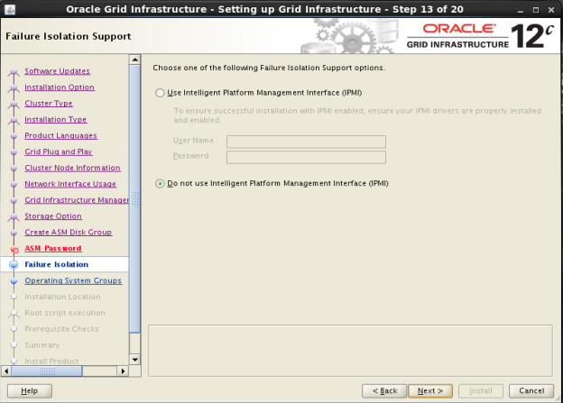

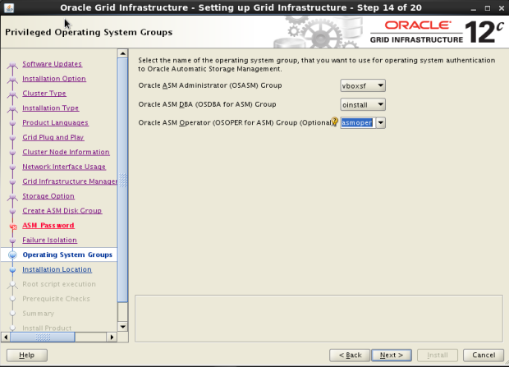

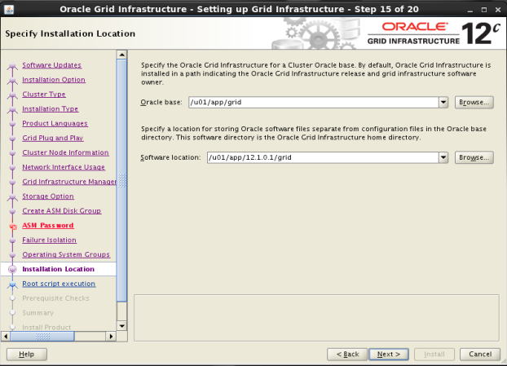

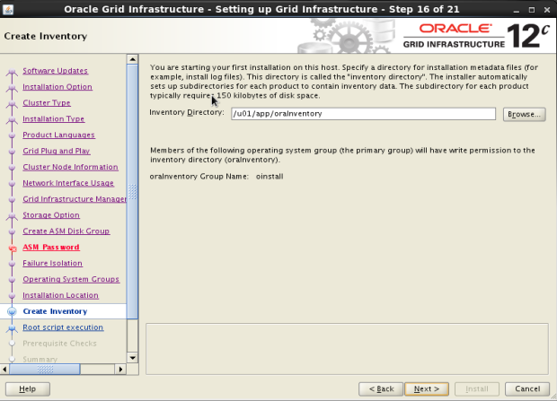

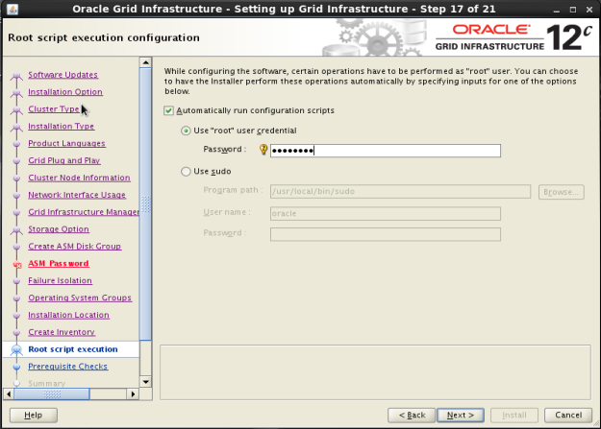

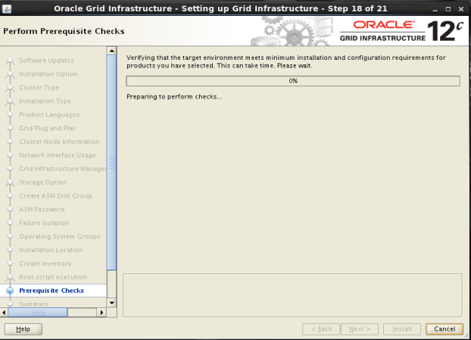

Once checks proceeded I have some prereqs failed, fix them up and rechecked and proceed for final go.

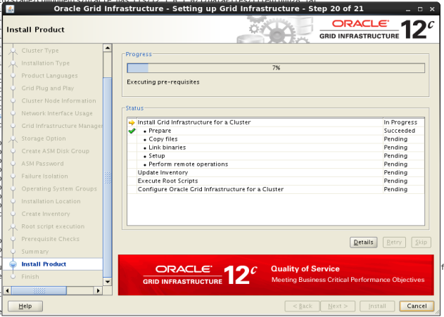

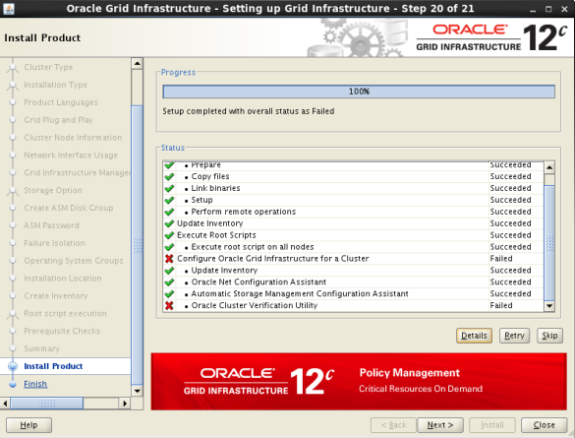

[oracle@oinfo12c-rac1 ~]$ crsctl stat resource -t
--------------------------------------------------------------------------------
Name Target State Server State details
--------------------------------------------------------------------------------
Local Resources
--------------------------------------------------------------------------------
ora.DATA.dg
ONLINE ONLINE oinfo12c-rac1 STABLE
ONLINE ONLINE oinfo12c-rac2 STABLE
ora.LISTENER.lsnr
ONLINE ONLINE oinfo12c-rac1 STABLE
ONLINE ONLINE oinfo12c-rac2 STABLE
ora.asm
ONLINE ONLINE oinfo12c-rac1 STABLE
ONLINE ONLINE oinfo12c-rac2 Started,STABLE
ora.net1.network
ONLINE ONLINE oinfo12c-rac1 STABLE
ONLINE ONLINE oinfo12c-rac2 STABLE
ora.ons
ONLINE ONLINE oinfo12c-rac1 STABLE
ONLINE ONLINE oinfo12c-rac2 STABLE
--------------------------------------------------------------------------------
Cluster Resources
--------------------------------------------------------------------------------
ora.LISTENER_SCAN1.lsnr
1 ONLINE ONLINE oinfo12c-rac2 STABLE
ora.LISTENER_SCAN2.lsnr
1 ONLINE ONLINE oinfo12c-rac1 STABLE
ora.LISTENER_SCAN3.lsnr
1 ONLINE ONLINE oinfo12c-rac1 STABLE
ora.cvu
1 ONLINE ONLINE oinfo12c-rac1 STABLE
ora.oc4j
1 OFFLINE OFFLINE STABLE
ora.oinfo12c-rac1.vip
1 ONLINE ONLINE oinfo12c-rac1 STABLE
ora.oinfo12c-rac2.vip
1 ONLINE ONLINE oinfo12c-rac2 STABLE
ora.scan1.vip
1 ONLINE ONLINE oinfo12c-rac2 STABLE
ora.scan2.vip
1 ONLINE ONLINE oinfo12c-rac1 STABLE
ora.scan3.vip
1 ONLINE ONLINE oinfo12c-rac1 STABLE
--------------------------------------------------------------------------------
[oracle@oinfo12c-rac1 ~]$

OUI- Command (Silent)
INFO: /u01/app/12.1.0.1/grid/oui/bin/runInstaller -jreLoc /u01/app/12.1.0.1/grid/jdk/jre -paramFile /u01/app/12.1.0.1/grid/oui/clusterparam.ini -silent -ignoreSysPrereqs -updateNodeList -setCustomNodelist -noClusterEnabled ORACLE_HOME=/u01/app/12.1.0.1/grid CLUSTER_NODES=oinfo12c-rac1,oinfo12c-rac2 "NODES_TO_SET={oinfo12c-rac1,oinfo12c-rac2}" CRS=false "INVENTORY_LOCATION=/u01/app/oraInventory" LOCAL_NODE=oinfo12c-rac2 -remoteInvocation -invokingNodeName oinfo12c-rac1 -logFilePath "/u01/app/oraInventory/logs" -timestamp 2013-07-01_08-01-09PM
Noticed that cssd starting in hub mode (flex cluster) need to explore on this.

[ohasd(15272)]CRS-1301:Oracle High Availability Service started on node oinfo12c-rac1.
2013-07-01 23:11:40.418:
[gpnpd(15405)]CRS-2328:GPNPD started on node oinfo12c-rac1.
2013-07-01 23:11:48.391:
[cssd(15462)]CRS-1713:CSSD daemon is started in hub mode
2013-07-01 23:11:51.254:

Next Install Orace RAC on this Grid Infrastructure nodes.

